# Ensemble Techniques

**Instructions:**

Please share your answers filled in-line in the word document. Submit code separately wherever applicable.

Please ensure you update all the details:

**Name:RAKESH SETHU NP Batch ID: 11052022_7.30PM**

**Topic: Ensemble Techniques**

1. **Business Problem**
   1. **What is the business objective?**
   2. **Are there any constraints?**
2. **Work on each feature of the dataset to create a data dictionary as displayed in the below image:**

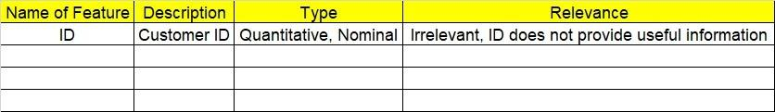

**2.1. Make a table as shown above and provide information about the features such as its data type and its relevance to the model building. And if not relevant, provide reasons and a description of the feature.**

**Using R and Python codes perform:**

1. **Data Pre-processing**

**3.1 Data Cleaning, Feature Engineering, etc.**

**3.2 Outlier Treatment.**

1. **Exploratory Data Analysis (EDA):**
   1. **Summary.**
   2. **Univariate analysis.**
   3. **Bivariate analysis.**
2. **Model Building**
   1. **Build the model on the scaled data (try multiple options).**
   2. **Perform Bagging, Boosting, Voting, Stacking on given datasets.**
   3. **Train and Test the data, use grid search cross validation, compare accuracies using confusion matrix.**
   4. **Briefly explain the model output in the documentation.**
3. **Share the benefits/impact of the solution - how or in what way the business (client) gets benefit from the solution provided.**
4. **Model Building**
   1. **Build the model on the scaled data (try multiple options).**
   2. **Perform Bagging Boosting (adaboost, fastadaboost, Xgboost), Stacking, Voting on the given datasets in Hands on Material.**
   3. **Train and Test the model and compare accuracies by building a confusion matrix and use different hyperparameters. Also use GridSearchCV to improve your model performance.**
   4. **Briefly explain the model output in the documentation.**

1. **Write about the benefits/impact of the solution - in what way does the business (client) benefit from the solution provided?**



**Problem Statements:**

1. Given is the diabetes dataset. Build an ensemble model to correctly classify the outcome variable and improve your model prediction by using GridSearchCV. You must apply Bagging, Boosting, Stacking, and Voting on the dataset.

**Business Objective:** Maximize accuracy of target variable (Class variable).

**Business Constraint:** Minimize computational time.

|  |  |  |  |
| --- | --- | --- | --- |
| Name of feature | Description | Type | Relevance |
| Number of times pregnant | Number of times pregnant | Ordinal | It is not important |
| Plasma glucose concentration | Glucose level | Ratio | it provides useful information |
| Diastolic blood pressure | Blood pressure | Interval | it provides useful information |
| Triceps skin fold thickness | Thickness of skin | Ratio | It is not important |
| 2-Hour serum insulin | Insulin | Ratio | Useful information |
| Body mass index | Mass index of body | Ratio | It is required |
| Diabetes pedigree function | Pedigree function | Ratio | It is required |
| Age (years) | Age of pregnant women | Ratio | it is not that useful information |
| Class variable | Boolean type | Ordinal | Targeted variable |



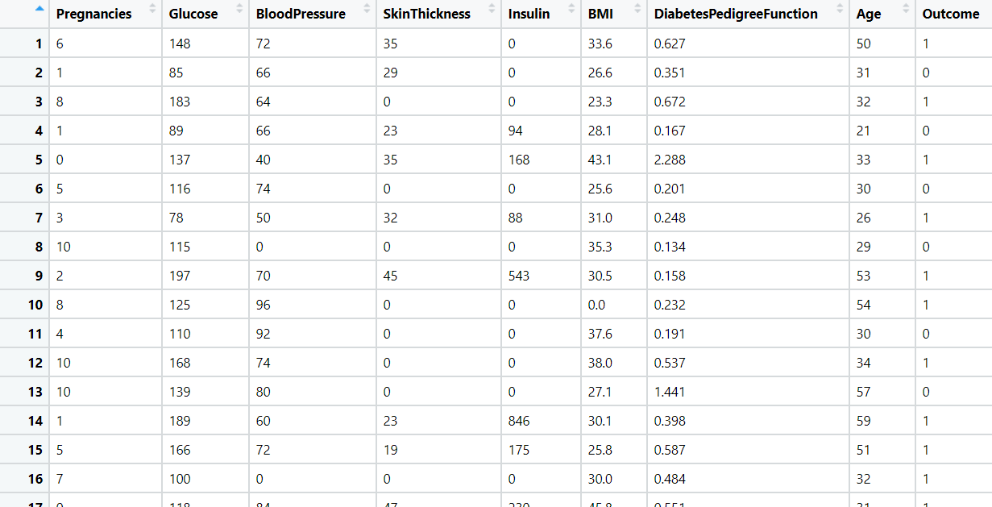

1. Most cancers form a lump called a tumour. But not all lumps are cancerous. Doctors extract a sample from the lump and examine it to find out if it’s cancer or not. Lumps that are not cancerous are called benign (be-NINE). Lumps that are cancerous are called malignant (muh-LIG-nunt). Obtaining incorrect results (false positives and false negatives) especially in a medical condition such as cancer is dangerous. So, perform Bagging, Boosting, Stacking, and Voting algorithms to increase model performance and provide your insights in the documentation.

**Objective:** Maximize the accuracy for classification as Benign and malignant.

Minimize the error in classification.

**Constraints:** Computation Complexity involved.

|  |  |  |  |
| --- | --- | --- | --- |
| Name of the Feature | Description | Type | Relevance |
| id | Patient ID | Nominal | Irrelevant, does not provide useful information |
| diagnosis | Result of all features (B-Benign & M-Malignant) | Ordinal | Relevant, can be used as Response variable |
| radius_mean | Radius Of Lump | Continuous | Relevant, Provide useful information |
| texture_mean | Mean Texture of Lump | Continuous | Relevant, Provide useful information |
| perimeter_mean | Mean Perimeter of Lump | Continuous | Relevant, Provide useful information |
| area_mean | Mean area of lump | Continuous | Relevant, Provide useful information |
| smoothness_mean | Mean smoothness of lump | Continuous | Relevant, Provide useful information |
| compactness_mean | Mean compactness of lump | Continuous | Relevant, Provide useful information |
| concavity_mean | Mean concavity of lump | Continuous | Relevant, Provide useful information |
| points_mean | mean points of lump | Continuous | Relevant, Provide useful information |
| symmetry_mean | mean symmetry of lump | Continuous | Relevant, Provide useful information |
| dimension_mean | mean dimension of lump | Continuous | Relevant, Provide useful information |
| radius_se | Standard error radius | Continuous | Relevant, Provide useful information |
| texture_se | Standard error texture | Continuous | Relevant, Provide useful information |
| perimeter_se | Standard error perimeter | Continuous | Relevant, Provide useful information |
| area_se | Standard error area | Continuous | Relevant, Provide useful information |
| smoothness_se | Standard error smoothness | Continuous | Relevant, Provide useful information |
| compactness_se | Standard error compactness | Continuous | Relevant, Provide useful information |
| concavity_se | Standard error concavity | Continuous | Relevant, Provide useful information |
| points_se | Standard error points | Continuous | Relevant, Provide useful information |
| symmetry_se | Standard error symmetry | Continuous | Relevant, Provide useful information |
| dimension_se | Standard error dimension | Continuous | Relevant, Provide useful information |
| radius_worst | worst radius measure | Continuous | Relevant, Provide useful information |
| texture_worst | worst texture measure | Continuous | Relevant, Provide useful information |
| perimeter_worst | worst perimeter measure | Continuous | Relevant, Provide useful information |
| area_worst | worst area measure | Continuous | Relevant, Provide useful information |
| smoothness_worst | worst smoothness measure | Continuous | Relevant, Provide useful information |
| compactness_worst | worst compactness measure | Continuous | Relevant, Provide useful information |
| concavity_worst | worst concavity measure | Continuous | Relevant, Provide useful information |
| points_worst | worst points measure | Continuous | Relevant, Provide useful information |
| symmetry_worst | worst symmetry measure | Continuous | Relevant, Provide useful information |
| dimension_worst | worst dimension measure | Continuous | Relevant, Provide useful information |

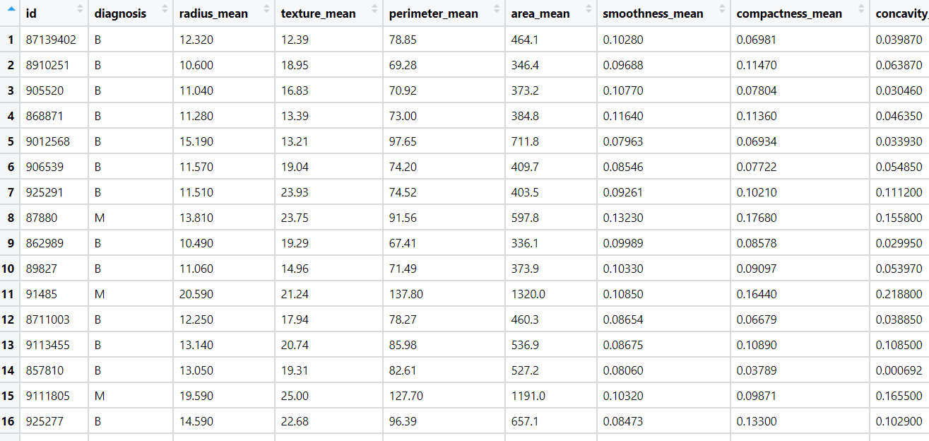

1. A sample of global companies and their ratings are given for the cocoa bean production along with the location of the beans being used. Identify the important features in the analysis and accurately classify the companies based on their ratings and draw insights from the data. Build ensemble models such as Bagging, Boosting, Stacking, and Voting on the dataset given.

**Objective:** Maximize the accuracy for classification.

Minimize the error in classification.

**Constraints:** Computation Complexity involved.

|  |  |  |  |
| --- | --- | --- | --- |
| Name of the Feature | Description | Type | Relevance |
| Company | Name of the company | Nominal | Irrelevant, does not provide much of information |
| Name | Company Location name | Nominal | Irrelevant, does not provide much of information |
| REF | Reference Number | Nominal | Irrelevant, does not provide much of information |
| Review | year of review | Ordinal | Relevant, can be used to categorize |
| Cocoa_Percent | Percentage of cocoa present in bean production | Continuous, ratio | Relevant, it provides useful info |
| Company_Location | Location of bean being used by company | Nominal | Irrelevant, does not provide much of information |
| Rating | Score for company out of 10 | Ordinal | Relevant, can be used as response variable |
| Bean_Type | Name of bean type | Nominal | Irrelevant, does not provide much of information |
| Origin | Origin of raw bean imported | Nominal | Irrelevant, does not provide much of information |

1. Data privacy is always an important factor to safeguard their customers' details. For this, password strength is an important metric to track. Build an ensemble model to classify the user’s password strength.

**Business Objective**: Maximize accuracy of target variable(character_strenght) and minimize classification error.

**Business Constraint**: Minimize computational time.

|  |  |  |  |
| --- | --- | --- | --- |
| Name of feature | Description | Type | Relevance |
| characters | Set of special characters in dataset | Nominal | Input variable |
| characters_strength | Strength of characters | Ordinal | Target variable |

